What is Planning

Hello all, please write introduction, can’t think of it.

# Need of planner

According to the times of India, there is requirement of as much as 3 lakh planners by 2031, and as per January 2019, we hardly have 5,000 qualified planners and as the urbanization is growing with fast speed, it surely will need more and more numbers of planners……..

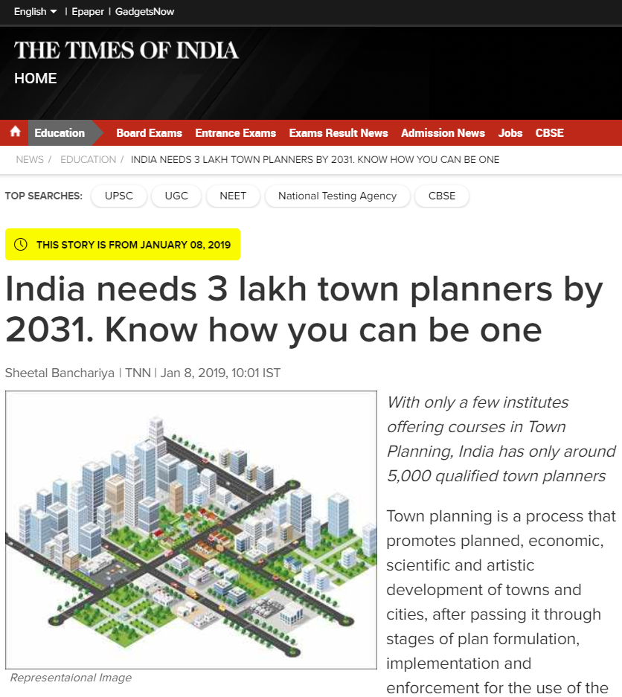

According to The economic times, India as on April 2015 has just 1 planner for 75,000 URBAN population ………………… and urban population is just 34% of total nation’s population.

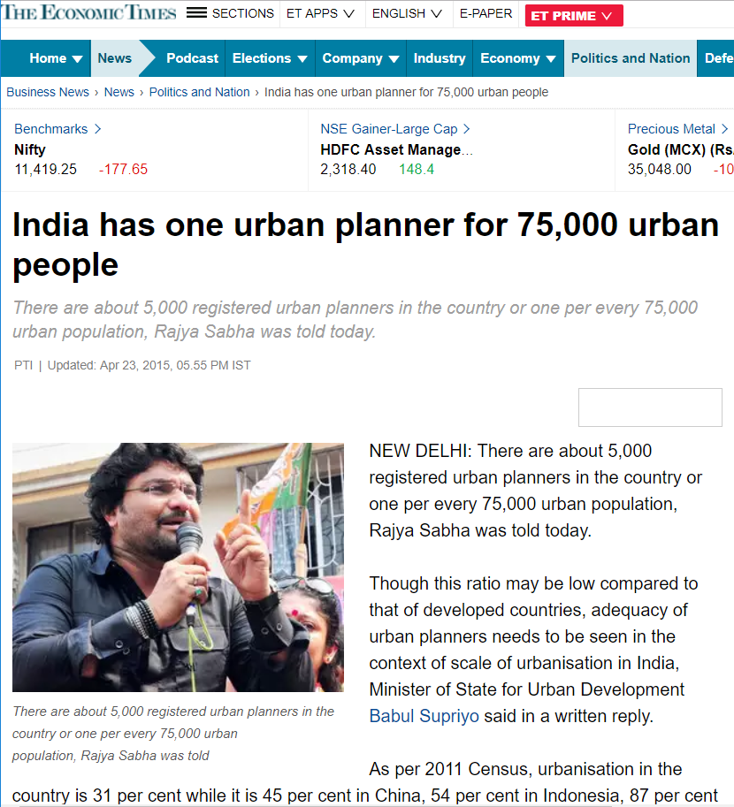

As on March 2016, The Hindu says, only for urban India, 1.1 million of planners are needed by 2020.

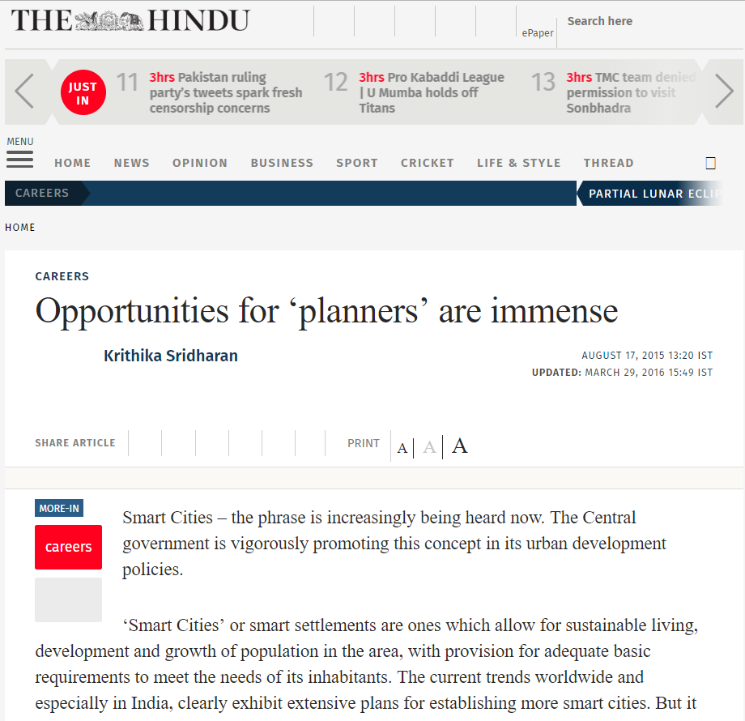

But wait a minute, what is planning??? Is it same as architecture??? Or is it Event planning??? Or financial planning??? Heath planning???

# Definition of Planning

Put 5-6 definition of planning with different source here.

For easy explanation, planning is for people, people are involved in some or other activity for their livelihood and entertainment etc and all these activities needs small or large space.

Take planning as an interrelation of “people”, “activity” and “spaces”.

People of different cast, creed, religion, gender, interest, education, race, ethnicity, income, etc do different economic, social etc activity at a place which is different in terms of location, accessibility, connectivity, climate, topography, natural resources, monitory value, applicable rules and regulations, etc etc etc. ……….. so many factors, aren’t they??? Imagine applying permutation and combination on this. Number of different types of people* number of different types of activities* number of different type of places…………. Won’t that be uncountable!!!!!! This is why it is said that planning is highly contextual. In chemistry no matter where on earth you perform the test, zinc will replace copper from copper sulphate solution, laws of force are defined in physics, in mathematics, 2+2 will never be 5, but in planning, same action done on two different individuals, or at two different location may produce drastically different results.

We definitely can’t bring everyone under one definition of development due to DIVERSITY. And if we can’t, the how do we define development????

# Development

What according to you will be your development??? When you get a better paying job??? A job giving more holidays??? Bigger house??? Expensive Cars and bikes??? Whatever it may be, one just need to learn the fact that the same word “development” will have a different meaning for the tribal community of Andaman and Niccobar Island.

Some of the formal definitions of planning are:

“The carrying out of building, engineering, mining or other operations in, on, over or under land or the making of any material change, in any building or land, or in the use of any building or land and includes sub-division of any land.” As per Model Regional and Town Planning and Development Law/ URDPFI page 418.

Put 3-4 more definition of development with different source here.

The paradigm change in definition of development can be seen as shift from economic perspective in 18th century to Human development perspective in 20th century , to social development perspective and today in 21st century, everyone is focused on Sustainable development.

To understand the complexity of “diversity”, consider a case where women of a town/ village have to travel at least 5 km every day to fetch water. As a third person, one will always want to help them, to provide water connection to every home. Isn’t it???? What if it comes out to be a bad decision for the women!!!! Yeah, you heard it right, even if they don’t have to travel 5km to fetch water, the women are not liking it, in fact haaaaaaating it. Puzzled… aren’t you??? The hidden fact was, the women were not allowed to step out of the home. Fetching water was only time when they got to interact with each other. Stunned!!!! This type of societies actually exists. Again……….Planning is highly contextual.

So its upto the individual, what type of planning on wants to do, advocacy planning??? Equity planning??? Rational Planning??? Incremental panning??? Community Based Planning??? Radical Planning??? Or post modernist planning???

# Promotion

Now, what are these types of planners, to know more about them, wait for the next episode. Please subscribe our channel to for more videos. Like this video if you want us to make more videos on the topic of hierarchy of plans, tools of planning, GIS, R programming language for planners, Python for planners, CAD, theories of planning, demographic tools, statistics for planners, land use zoning, LULC, Network analysis, jobs which are meant for planners, roles planners can play etc etc etc… and since, there are very less study material available for planning, please share the video with your friend and colleagues ……. After all resource are limited, but knowledge isn’t.

Apart from this, please tell us in the comment section on what topic should we make videos on.